Design of a remote controlled car
By Serban Cordis
Lucian Palcu

Submitted for Digilent Digital Design Contest
October 7, 2006

Instructor: Prof. Dr. Ing. Mircea-Alexandru Dabacan
Technical University Cluj-Napoca

Introduction

Our design demonstrates multiple uses of the Cerebot platform like communication over the serial port, sending the proper sequence of signals over the ports to command stepper motors and generating external interrupts. All these capabilities and more others can be used in personal reasons or educational reasons. In order to demonstrate these capabilities we made a toy car using two stepper motors commanded by the Cerebot microcontroller. The robot’s brain is the Cerebot , which has in its flash memory a program with whose help turn the serial signals received from the computer into signals for commanding the stepper motors. The design reaches most of its objectives and can be reused with some exterior design changes to make car toys for children.
The design could be improved by replacing the rs232 communication between PC and Cerebot with a wireless one, for more mobility and eventually to replace the PC with a small terminal that sends singnals to control our toy car. The design requires a Computer which any OS which have capabilities for sending serial singnals over RS232. Another tools required are a Cerebot platform, two stepper motors and the two driver boards for commanding the motors.

Background

Stepper motor basics:

A stepper motor is an electromechanical device which converts electrical pulses into discrete mechanical movements. The shaft of a stepper motor rotates in discrete step increments when electrical command pulses are applied to it in the proper sequence. The motors rotation has several direct relationships to these applied input pulses. The sequence of the applied pulses is directly related to the direction of motor shafts rotation. The speed of the motor shafts rotation is directly related to the frequency of the input pulses and the length of rotation is directly related to the number of input pulses applied.

Stepper Motor Advantages and Disadvantages

Advantages
1. The rotation angle of the motor is proportional to the input pulse.
2. The motor has full torque at standstill (if the windings are energized)
3. Precise positioning and repeatability of movement since good stepper motors have an accuracy of 3 – 5% of a step and this error is non cumulative from one step to the next.
4. Excellent response to starting/stopping/reversing.
5. Very reliable since there are no contact brushes in the motor. Therefore the life of the motor is simply dependant on the life of the bearing.
6. The motors response to digital input pulses provides open-loop control, making the motor simpler and less costly to control.
7. It is possible to achieve very low speed synchronous rotation with a load that is directly coupled to the
shaft.
8. A wide range of rotational speeds can be realized as the speed is proportional to the frequency of the input pulses.

Disadvantages
1. Resonances can occur if not properly controlled.
2. Not easy to operate at extremely high speeds.

Open Loop Operation

One of the most significant advantages of a stepper motor is its ability to be accurately controlled in an open loop system. Open loop control means no feedback information about position is needed. This type of control eliminates the need for expensive sensing and feedback devices such as optical encoders. Your position is known simply by keeping track of the input step pulses.

When to Use a Stepper Motor

A stepper motor can be a good choice whenever controlled movement is required. They can be used to advantage in applications where you need to control rotation angle, speed, position and synchronism. Because of the inherent advantages listed previously,stepper motors have found their place in many different applications. Some of these include printers, plotters, highend office equipment, hard disk drives, medical equipment, fax machines, automotive and many more.

Motor Phases

Usually stepper motors have two phases, but three- and five-phase motors also exist. A bipolar motor with two phases has one winding/phase and a unipolar motor has one winding, with a center tap per phase. Sometimes the unipolar stepper motor is referred to as a “fourphase motor”, even though it only has two phases. Motors that have two separate windings per phase also exist—these can be driven in either bipolar or unipolar mode. A pole can be defined as one of the regions in a magnetized body where the magnetic flux density is concentrated. Both the rotor and the stator of a step motor have poles.
The figure below contains a simplified picture of a two-phase stepper motor having 2 poles for each phase on the stator, and 2 poles on the rotor.
The two versions are unipolar (the first) and bipolar wound (the second). This is only an example for educational purposes, in practice several more poles are added to both the rotor and stator structure in order to increase the step resolution to provide smaller stepping angles. The step angle is 2pi radians (360 degrees) divided by the number of stator poles and the number of phases.

Stepping Modes

The most common drive modes are:
• Wave Drive (1 phase on)
• Full Step Drive (2 phases on)
• Half Step Drive (1 & 2 phases on)
• Microstepping

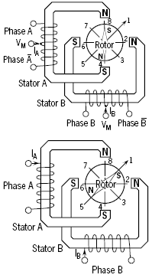 | In Wave Drive only one winding is energized at any given time. The stator has the sequence A → B → A → B and the rotor steps from position 8 → 2 → 4 → 6.  In Full Step Drive you are energizing two phases at any given time. The stator is energized according to the sequence AB → AB → AB → AB and the rotor steps from position 1 → 3 → 5 → 7 . Full step mode results in the same angular movement as 1 phase on drive but the mechanical position is offset by one half of a full step.  Half Step Drive combines both wave and full step (1&2 phases on) drive modes. Every second step only one phase is energized and during the other steps one phase on each stator. The stator is energized according to the sequence AB → B → ΑB → Α→ AB → B → AB → A and the rotor steps from position 1 → 2 → 3→ 4 → 5 → 6 → 7 → 8. This results in angular movements that are half of those in 1- or 2-phases-on drive modes. Half stepping can reduce the resonance which can be experienced in the
previous drive modes.

In Microstepping Drive the currents are continuously varying to be able to break up one full step into many smaller discrete steps. A sine shaped signal gererated by PWM is commonly used.

Single Step Response and Resonances

When one step pulse is applied to a stepper motor the rotor behaves in a manner as defined by the above curve. The step time is the time it takes the motor shaft to rotate one step angle once the first step pulse is applied. This step time is highly dependent on the ratio of torque to inertia (load) as well as the type of driver used. Since the torque is a function of the displacement it follows that the acceleration will also be. Therefore, when moving in large step increments a high torque is developed and consequently a high acceleration. This can cause overshots and ringing. The settling time is the time it takes these oscillations or ringing to cease. In certain applications this phenomena can be undesirable. It is possible to reduce or eliminate this behaviour by microstepping the stepper motor. Stepper motors can often exhibit resonance at certain step rates. This can be seen as a sudden loss or drop in torque at certain speeds which can result in missed steps or loss of synchronism. It occurs when the input step pulse rate coincides with the natural oscillation frequency of the rotor. The resonance comes from its basic construction and therefore it is not possible to eliminate it completely. It is also dependent upon the load conditions and drive modes.

Bipolar vs Unipolar Drive

The main difference between bipolar and unipolar drives are the way that the motor windings are used.
In Bipolar mode the current can be reversed by the driver circuit and all the turns in the windins are used to generate force. A H-bridge is usually used as a driver.
In Unipolar mode the current flows between the center-tap of the windings to one of the other ends. There is no need to use a H-bridge, because the electro-magnetic force generated by the current can be reversed by using one or the other end of the winding. This simplifies the drive circuit, at the cost of halving the torque generated by the same current.

Mechanical Parameters

The performance of a stepper motor system (driver and motor) is also highly dependent on the mechanical parameters of the load. This is typically frictional, inertial or acombination of the two. Friction is the resistance to motion due to the unevenness of surfaces which rub together. A minimum torque level is required throughout the step in over to overcome this friction. Increasing a frictional load lowers the top speed, lowers the acceleration and increases the positional error. Inertia is the resistance to changes in speed. A high inertial load requires a high inertial starting torque and the same would apply for braking. Increasing an inertial load will increase speed stability, increase the amount of time it takes to reach a desired speed and decrease the maximum self start pulse rate. The rotor oscillations of a stepper motor will vary with the amount of friction and inertia load. Because of this relationship unwanted rotor oscillations can be reduced by mechanical damping. However it is more often simpler to reduce these unwanted oscillations by electrical damping methods.

RS-232 protocol

In telecommunications, RS-232 is a standard for serial binary data interconnection between a DTE (Data terminal equipment) and a DCE (Data Circuit-terminating Equipment). It is commonly used in computer serial ports.
In RS-232, data is sent as a time-series of bits. Both synchronous and asynchronous transmissions are supported by the standard. In addition to the data circuits, the standard defines a number of control circuits used to manage the connection betwen teh DTE and DCE. Each data or control circuit only operates in one direction, that is, signalling from a DTE to the attached DCE or the reverse. Since transmit data and receive data are separate circuits, the interface can operate in a full duplex manner, supporting concurrent data flow in both directions. The standard does not define character framing within the data stream, or character encoding.
The RS-232 standard defines the voltage levels that correspond to logical one and logical zero levels. Valid signals are plus or minus 3 to 15 volts. The range near zero volts is not a valid RS-232 level; logic one is defined as a negative voltage, the signal condition is called marking, and has the functional significance of OFF. Logic zero is positive, the signal condition is spacing, and has the function ON. The standard specifies a maximum open-circuit voltage of 25 volts; signal levels of ±5 V, ±10 V, ±12 V, and ±15 V are all commonly seen depending on the power supplies available within a device. Circuits driving an RS-232-compatible interface must be able to withstand indefinite short circuit to ground or to any voltage level up to 25 volts. The slew rate, or how fast the signal changes between levels, is also controlled.
Because the voltage levels are higher than logic levels used by integrated circuits, special intervening circuits are required to translate logic levels, and to protect circuitry internal to the device from short circuits or transients that may appear on the RS-232 interface. For functional communication through a serial port interface, conventions of bit rate, character framing, communications protocol, character encoding, data compression, and error detection, not defined in RS 232, must be agreed to by both sending and receiving equipment.

3.Design

The project consists of a toy car controlled via rs232 protocol from a personal computer or other device that has the protocol implemented. The commands are simple, one character in length, and make the car to performa certain tasks :
- move forward/backward continously or for a certain number of steps
- start/stop one of the motors
- modify the motors’ stepping rate
- change the step mode
- automatically change the cruise direction after a colision
- enable/disable colision detection
- turn left/right
The entire project is based on the Digilent’s Cerebot which is responsible for the motor control and establishing communication with the PC.

Block Diagram

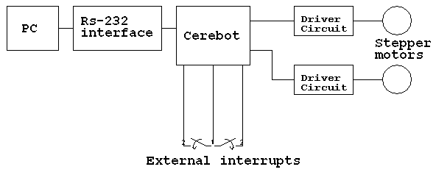

Motor control:

Two home-made motor driver boards were used. Their schematic is presented below:
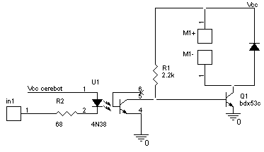

When a ‘0’ is applied to the input, the diode from the optocoupler is forward biased and the receiver transistor steals the base curent from the power darlington and the motor phase is de-energized. A ‘1’ to the input will underbias the diode, the optocoupler will stop stealing the darlington’s base curent. The power transistor will go into conduction and the motor phase will be energized. Protection from inverse voltages is provided by the diode mounted on the motor’s terminals.
Four circuits are needed to make up a complete unipolar motor driver.
I have chosen these parts for their availability and low price. The power dralingtons can handle up to 8A and can disipate about 60W with a properly designed heatsink so it can be used as a power switch in altmost any design. Fast-on connectors are used to make the electrical connection between the motorphases and the driver circuit. These make debugging a lot easier.
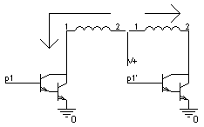 | The unipolar drive mode was chosen because of it’s simplicity and cost effectiveness.  The motors used have 2 phases, each of them with two windings connected in series to obtain the center-tap. This is connected to the positive power supply and the other endings are connected to ground through the driver circuit’s transistors.
The driver boards are connected to Cerebot’s connectors JA and JB which contain the pins 7, 6, 4, 5 of port D, 4 and 7, 6, 5, 4 of port B. The step sequence is stored in an array of 8 bit values that are applied to the four most significant bits of ports B and D. A mask must be used when sending the sequence out the ports, otherwise we will change all of ports’ B and D bits and risk interfering with another process that is using those ports.

FullStep function:

void mot1_fs_fw(){
if (step1<3) { step ++;
PORTB=(PINB&0x6F)|(fs_b[step1]&0x90);
PORTD=(PIND&0x5F)|(fs_d[step1]&0xA0);
}
else { step1=0;
PORTB=(PINB&0x6F)|(fs_b[step1]&0x90);
PORTD=(PIND&0x5F)|(fs_d[step1]&0xA0);
}
}

Step1 is used for counting the steps. When it reaches the last stap it starts from the first one. The array elements are applied through a mask, not directly.
There are also other functions for stepping backward and stepping in a different mode, wave drive, for lower power consumption. All functions are duplicate for the second motor.
For continous movement of the motors timer0 and 2 output compare interrupt service routines are used. The output compare level can be adjusted in order to obtaint the desired stepping frequency by modifying the OCR0 and OCR2 values.

interrupt [TIM0_COMP] void timer0_comp_isr(void)
{ PORTE.5=~PINE.5;
if ((enable_cnt)&&(mot1_cnt<mot1_cnt_lim)) mot1_cnt++;
if (mot1_dir) if (mot1_fs_mode) mot1_fs_fw();
else mot1_wd_fw();
else if (mot1_fs_mode) mot1_fs_bw();
else mot1_wd_bw();
}
The routine executes a specific function coresponding to the selected step mode and direction. These are selected by the flags mot1_fs_mode, mot2_fs_mode, mot1_dir, mot2_dir.
The routine also counts the steps made by the motor. This is very useful when we want to move for a given distance.
Two timers are used for controling the motors because different output compare levels are needed if different stepping rates are required. Using only one timer/counter will result in both motors moving with the same speed which will make changing the cruise direction impossible.
Enabling and disabling the routines are made by modifying the timer interrupt mask registers.
The following instructions are used for stopping the motors:

void mot1_stop(){
TIMSK=TIMSK &0xFC;
PORTB=PINB&0x9F;
PORTD=PINB&0xAF;
}

void mot2_stop(){
TIMSK=TIMSK &0x3F;
PORTB=PINB&0x6F;
PORTD=PINB&0x5F;
}
They basically make the microcontroler ignore it’s timer 0 and 2 output compare interrupt requests and turn off the current through the motors windings.

Turning is performed in the following manner:
void fwd_left(){
OCR0=200;
OCR2=140;
mot1_fs_mode=1; mot1_dir=1;
mot2_fs_mode=1; mot2_dir=1;
TIMSK=TIMSK |0xc0;//start M2
TIMSK=TIMSK |0x03;//start M1
delay_ms(proc_time);
mot1_stop();
mot2_stop();
}
This will set different speeds on the two motors and will let them run in the same direction for a certain amount of time and then will stop them.

RS232 communication is made based on the Digilent’s RS232 converter module used for converting the voltage required for the protocol to the voltage levels used on the board. The UART units built in the Atmega64 controler are responsible for handling the incomming transmissions. We used the UART1 unit instead of the 0 unit. This way you don’t have to disconnect the rs232 module from the cerebot everytime you want to program the it.
The received message causes an interrupt that will stop the normal program flow, will read the incoming commands and respond to them.

char getchar1(void){
char data;
while (rx_counter1==0);
data=rx_buffer1[rx_rd_index1];
if (++rx_rd_index1 == RX_BUFFER_SIZE1) rx_rd_index1=0;
#asm("cli")
--rx_counter1;
#asm("sei")
return data;
}

interrupt [USART1_RXC] void usart1_rx_isr(void){
char status,data,a;
status=UCSR1A;
data=UDR1;
if ((status & (FRAMING_ERROR | PARITY_ERROR | DATA_OVERRUN))==0){
rx_buffer1[rx_wr_index1]=data;
if (++rx_wr_index1 == RX_BUFFER_SIZE1) rx_wr_index1=0;
if (++rx_counter1 == RX_BUFFER_SIZE1){
rx_counter1=0;
rx_buffer_overflow1=1;

};
modify_flags(getchar1());
};
}

The interrupt service routine calls getchar1() which reads the data from the input buffer and sends it to the function that controls the process according to the message received.

Collision detection is provided by two switches placed on the front of the toy car which generate an interrupt each time they are pressed. The interrupt service routine makes the car to go backward-left or backward-right for a defined numer of steps, and then to continue moving forward. A filter is used on the external interrupts inputs to avoid multiple interrupt generation caused by the wire inductance between the cerebot’s port and the external switch. Digilent’s digital input module board is a very good candidate for this task. Not using such a filter will most likely result in multiple interrupt.
The external interrupt service routine:

interrupt [EXT_INT7] void ext_int7_isr(void){
mot1_dir=mot2_dir=1;
mot1_fs_mode=mot2_fs_mode=1;
OCR0=200;OCR2=140;
mot1_cnt=mot2_cnt=0;
enable_cnt=1;
TIMSK=TIMSK |0x03;//enable timer0 for the motor 1
TIMSK=TIMSK |0xc0;//enable timer2 for the motor 2
enable_sync=1;
}

It will enable counting the steps the motors will make and make them go in the other way with different step rates in order to turn the car. After the step limit is reached the motors will synchronize their speed and will continue moving in the original direction.
Syncronizing is made in the main() function, in the while(1) {} loop:

while (1){
if ((enable_sync)&&( (mot1_cnt>=mot1_cnt_lim) ||(mot1_cnt>=mot1_cnt_lim) )) {
OCR0=OCR2=default_speed;
enable_sync=0;
mot1_dir=!mot1_dir;
mot2_dir=!mot2_dir;
}

Transmission system:
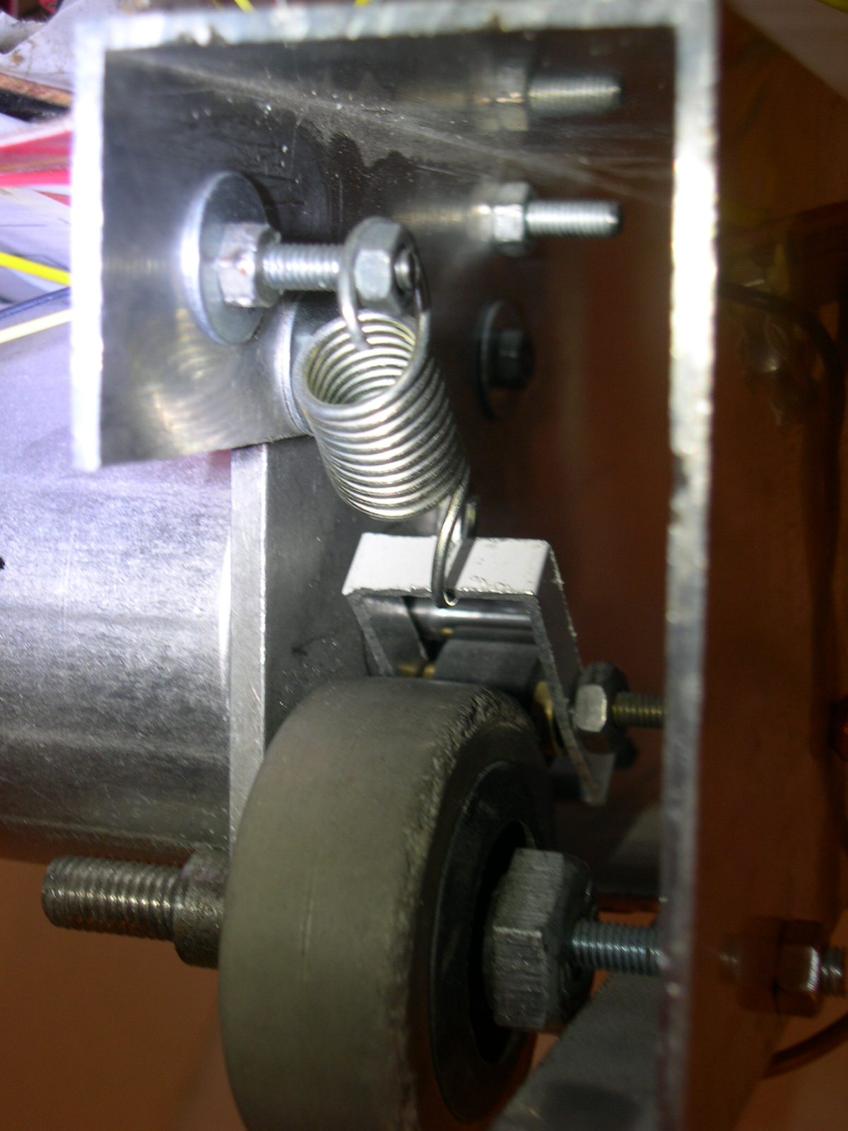
The rotational movement from the stepper motors is transmitted to the wheels with the mechanism shown in the picture above.

This mechanism is composed of a pinch roller salvaged from an old VCR mounted on a steel axles attached on a rectangular frame. A spring is used to keep the pinch roller in place and maintain a sufficient pressure between the motor’s shaft and the car’s wheel.

Construction details:

Two rectangular aluminium profiles held together at a 115mm / 4.5” distance with threaded bars. The motors are attached on the front side of the profiles together with the transmission system. Thick screws are used as axles. The rear side is sustained by a caster wheel which makes turning a lot easier. The front side of the prototype has two push-to-make switches that detect the collisions.
The Cerebot and the driver boards are fixed on the top of the assembly.

Discussion

No serious problems occurred during the design and implementation processes. We tried using the external interrupts without the debouncing filter but they failed to perform well, which was expected.
The program requires minimal modifications to accommodate the digilent H-bridges. The arrays holding the step sequence have to be modified in order to give the appropriate commands.
We were unable to find powerful enough batteries or the motors’ power supply so we had to supply them through a 2 conductor cable. The communication is also through a UTP cat5 cable.
To make the car completely independent, a battery must be provided, and a wireless interface for the communication protocol must be implemented.
Design tools used:
CVAVR - source code editing and compiling
- serial communication
Digilent’s AVR programmer – loading the binary code into the cerebot’s program memory
Orcad Schematic Capture, PSpice and Layout: editing/simulating and designing the layout for the motor driver board
Half Stepping and microstepping can be implemented if a smoother movement is a must.

Conclusion:

Working on the project made us realise the wide spread of applications in which the Cerebot can be easily used. We also gained precious experience during the design and programming phases.

References

www.digilentinc.com
http://www2.tech.purdue.edu/ecet/courses/eet209/
www.atmel.com
http://www.cs.uiowa.edu/~jones/step/

